HOW TO EARN

BOX TOPS MAKES IT EASY.
All you need is your phone! Download the Box Tops app, shop as you normally would, then use the app to scan your store receipt within 14 days of purchase. The app will identify Box Tops products on your receipt and automatically credit your school’s earnings online. Twice a year, your school will receive a check and can use that cash to buy whatever it needs!

Do you need to enroll your school? Find out how https://www.boxtops4education.com/enroll.

HOW IT WORKS
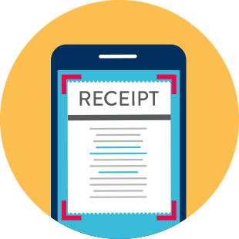

BUY ScaN eARN

BOX TOPS PRODUCTS Your Receipt cASH FOR YOUR SCHOOL

Look for the logo! Tap the scan button to snap a Box Tops earnings are

Photo of your receipt within 14 identified and automatically

days of purchase. updated online.

EARN BOX TOPS WITH DIGITAL RECEIPTS
Great news! If you shop for groceries online or have digital receipts, you can submit your email receipts to earn Box Tops for your school! Visit the app or https://www.boxtops4education.com/ for more details and to see a full list of
participating retailers.

